6A^{th} Grade: Unit 4, Lesson 3

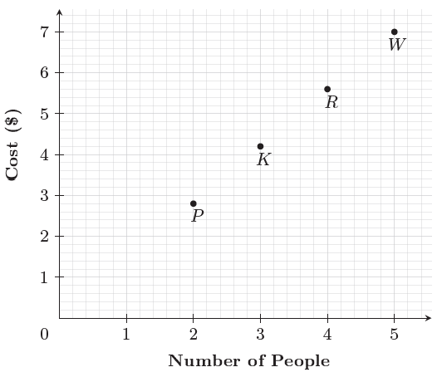
- What does point W represent on the graph?

When there are 5 people, the cost is $7

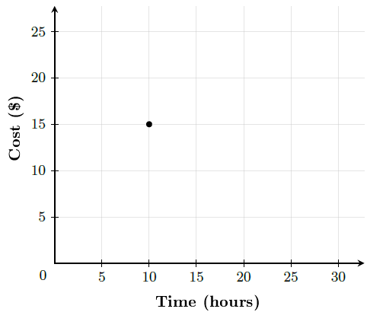
- What is the ordered pair represented by the point on the graph?

(10,15)

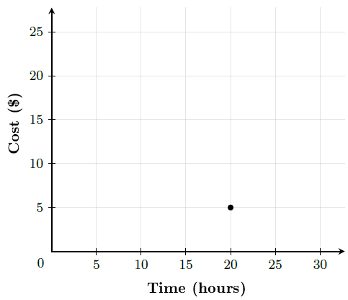
- What is the y-coordinate of the point shown?

5

